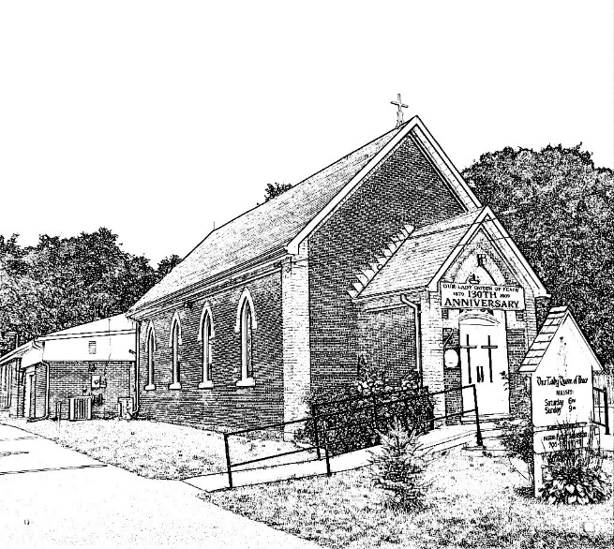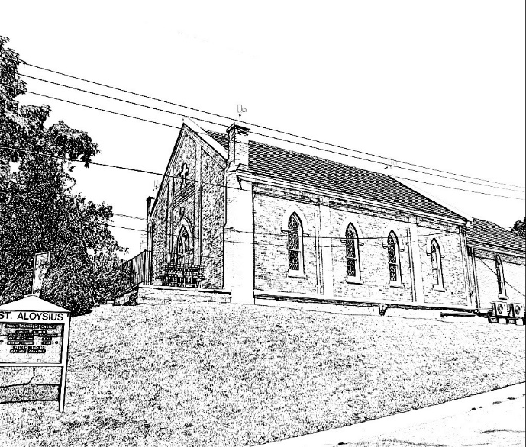

*Mission: Welcome, Worship and Witness*

*Mission: To show the love of Christ through*

*discipleship, fellowship, and worship.*

Our Lady Queen of peace Church St. Aloysius Church

18 Need Street, Bobcaygeon 41 John Street, Fenelon Falls

<https://ladyqueenofpeacebobcaygeon.ca/> <http://staloysiusfenelonfalls.ca/>

**Parish Priest: Fr. Luis Lapinid**

**Deacon Emeritus: Rev. Bill Steenburgh**

**Deacon: Rev. Sean Gallagher**

**Rectory & Parish Office: 41 John Street St. P.O. Box 340, Fenelon Falls, ON K0M 1N0**

**Telephone: 705-887-4149**

**Email:** [**office@staloysiusfenelonfalls.ca**](mailto:office@staloysiusfenelonfalls.ca)

**Parish Secretary: Pam Guzzi Parish Bookkeeper: Valerie Flynn**

**Parish Community Leaders**

**Bobcaygeon**

CWL Anne Boyd 705-879-4085

Music Loretta Falls 705-738-4676

Ann Pallett 705-454-2871

Finance

Food Bank Jose Foot 705-738-9259

Knights of Columbus Joe Grace 705-887-9112

Screening Committee Cathy Collins 705-738-9577

Audrey McLaughlin 705-738-4021

Readers Audrey McLaughlin 705-738-4021

Maintenance David Timmermans 647-328-4650

Cemetery Mike Byrne 705-887-6376

**Fenelon Falls**

Ladies Group Philomena Childs 705-887-6472

Music

Finance John Sutton 705-887-9494

Food Bank & Flowers Laura Sutton 705-887-9494

Garden Linda McCarthy 705-887-7604

Knights of Columbus Joe Grace 705-887-9112

Screening Committee John Byrne 705-454-2579

Bob Smith 705-934-5776

Readers Anna Croxall 705-887-4149

Eucharistic Ministers Anna Croxall 705-887-4149

Maintenance David Timmermans 647-328-4650

Cemetery Mike Byrne 705-887-6376

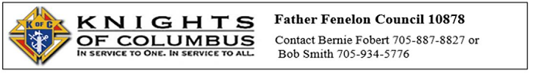

|  |  |  |  |
| --- | --- | --- | --- |
| Sat. Jan 14th | 4:00 p.m.  6:00 p.m. | *FF*  *BC* |  |
| Sun. Jan 15th | 9:00 a.m.  11:00 a.m. | *BC*  *FF* | Holy Mass † Jim Ehmann by Bonnie Ehmann & Family  Holy Mass † Bruce & David Finlay by Evelyn Finlay |
| Wed. Jan 18th |  |  | ***NO MASS*** |
| Thurs. Jan 19th | 9:00 a.m. | FF |  |
| Fri. Jan 20th | 9:00 a.m.  1:00 p.m. | *FF*  *BC* | For the Intentions of Cathy MacRae as requested by Nancy Dunk |
| Sat. Jan 21st | 4:00 p.m.  6:00 p.m. | *FF*  *BC* |  |
| Sun. Jan 22nd | 9:00 a.m.  11:00 a.m. | *BC*  *FF* | For Laverne Lemoir for his 90th Birthday by Lorraine Perdue |

***Funds Collected January 2nd to January 8th***

**OLQP** Regular Offering $ 560.00

Canada Helps $ 0.00

**St. Aloysius** Regular Offering $ 599.25

Canada Helps $ 0.00

**Let us remember in our prayers all who are sick**

**Bobcaygeon** – Paul Sirois, Lynn Lebel, Joseph Ehmann, Judith Dann, Helen Vozza, Anne Hayes, Barbara Gartner.

**Fenelon Falls** – P. McKeaveney, Rita Lenton, Pat Howards, Patrick White, Alan Visneskie, Lorraine Smith, Bob Smith, Erica Dutrieue & Jim Saigeon.

St. Yvo of Chartres-------December 23  
Sts. Adam and Eve-------December 24  
St. Stephen, First Martyr-------December 26  
St. John the Evangelist, Apostle-------December 27  
The Holy Innocents -------December 28  
St. Thomas Becket, Martyr-------December 29  
St. David, King-------December 29  
St. Sabinus-------December 30  
Pope St. Sylvester-------December 31  
**St. Catherine Laboure-------December 31**

August 08: [St. Dominic](http://www.holyspiritinteractive.net/dailysaint/august/0808.asp)   
August 09: [Blessed John of Reiti](http://www.holyspiritinteractive.net/dailysaint/august/0809.asp)   
August 10: [St. Lawrence](http://www.holyspiritinteractive.net/dailysaint/august/0810.asp)   
August 11: [St. Clare](http://www.holyspiritinteractive.net/dailysaint/august/0811.asp)   
August 12: [St. Porcarius and Companions](http://www.holyspiritinteractive.net/dailysaint/august/0812.asp)  
  
  
  
  
  
  
  
June 23: [St. Joseph Cafasso](http://www.holyspiritinteractive.net/dailysaint/june/0623.asp)   
June 24: [The Birth of St. John the Baptist](http://www.holyspiritinteractive.net/dailysaint/june/0624.asp)



**Catechism in a Year Podcast**

Do you want to learn and experience the fullness of our faith?

Listen to the daily podcast on your favourite podcast provider or on YouTube by searching for “The Catechism in a Year with Fr. Mike Schmitz”.

This program is provided by Ascension Press and can also be accessed at [The Catechism in a Year – Ascension (ascensionpress.com)](https://ascensionpress.com/pages/catechisminayear) then click on the link “Listen Now”.

Thomas Merton once said, “If you want to know who I am, do not ask me where I live or what I like to eat or how I comb my hair. Ask me what I am living for.”

What are we living for? What force is directing my life? Some, after the end of their education, look beyond college or graduate studies to go on with life. That is a valuable goal. But is it enough? Others might be living for retirement. Such a purpose would be understandable and deserved. But is it enough? Still might be living for their grandchildren. What a joy they are. But is it enough to live for?

John the Baptist might help us as we struggle with Merton’s question, because he is very clear about what he is living for. He is living to be a part of God’s plan for the world. John aimed at bringing that plan of God to fruition. As he says in the gospel, “I came baptizing with water so that he might be known to Israel.” John was living to point Jesus for us!

The lives we live have a part to play in God’s plan for the world. The knowledge we have acquired or learned from education is more than just a way to earn a living. It is a part of God’s plan to make a better world. Finding the way that we can use our knowledge for God’s purposes gives meaning to our life.

God is able to use our simple actions for his own good purpose. It is something worth living for. There is no greater joy than being able to participate in God’s plan to love and save the world.

* Fr. Luis

**OLQP**

**Food Bank:** Thank you to those who were able to share their Christmas celebration with those needing support from our community Food Bank. Your donations were deeply appreciated. The need is very real and our client base continues to grow as we foresee a challenging winter ahead. While we will not be able to have Church collections for the next little while, there are collection boxes at both our grocery stores and a small donation when grocery shopping would go a long way. The Food Bank is also open from 9:30 a.m. to 11:00 a.m. on Wednesday and volunteers would be happy to accept any donations. The Food Bank is on the ground floor of the Lions Hall on Main Street. Prayer is powerful and always welcome!

# Pro-Life Corner

**For the month of January let us throw ourselves on the mercy of God, our Creator, and unceasingly ask Him for an end to abortion and euthanasia.** **Then and only then can we have peace in our hearts, in our families, and in the streets of America.**

**Jan. 1 – You are called to stand up for life! To respect and defend the mystery of life always and everywhere, including the lives of unborn babies and giving real help and encouragement to mothers in difficult situations. You are called to work and pray against abortion.**

**Jan. 8- “The Pro-Life cause is the pre-eminent cause of our time, and this struggle between the gospel of life and the culture of death will determine the destiny of mankind.” ~ Peter Garrett**

**Jan. 15 – Assisted suicide means administering lethal overdoses or otherwise causing to die those whose lives are judged useless or lacking in quality.  Life must be valued from conception to natural death.  Join Pro-life today.**

**Jan. 22 – “Moral principles do not depend on a majority vote.  Wrong is wrong, even if everybody is wrong. Right is right, even if nobody is right.” Archbishop Fulton J. Sheen. Abortion is just wrong.**

**Jan. 29 – We cannot diminish the value of one category of human life-the unborn-without diminishing the value of all human life…there is no cause more important.   Ronald Reagan**

**Livestreaming of the Mass for the Second Sunday in Ordinary Time**

The Mass for the Second Sunday in Ordinary Time will be live-streamed from the Cathedral of St. Peter-in-Chains starting at 5:00 p.m. on Saturday, January 14, 2023.   The Mass will be available thereafter on the YouTube channel for the Roman Catholic Diocese of Peterborough.

Please click the link below to join in prayer:

<https://youtu.be/xeF39Mp4f9E>

**NEW**

***Online Donations***

As we approach the winter months, we ask that you consider continuing your donations to St. Aloysius and Our Lady Queen of Peace through our online donation options.

**ETRANSFERS**

You can now send etransfers to our

parish office emails and the amounts will be deposited directly to the parish bank account and added to your annual charitable donation receipts. No security questions required.

***To send an etransfer to Our Lady Queen of Peace***

[office@ladyqueenofpeacebobcaygeon.ca](mailto:office@ladyqueenofpeacebobcaygeon.ca)

***To send an etransfer to St. Aloysius***

[office@staloysiusfenelonfalls.ca](mailto:office@staloysiusfenelonfalls.ca)

**CANADA HELPS**

Canada Helps allows you to make a

donation by clicking the appropriate link below. You can set up weekly, monthly or one-time donations in secure manner.

***Click the link below to donate to Our Lady Queen of Peace:***

<https://www.canadahelps.org/en/dn/48026>

***Click the link below to donate to St. Aloysius:***

<https://www.canadahelps.org/en/dn/48211>

Weekly Prayer Group Meeting

Come and Pray with us every Wednesday & Friday. Everyone is welcome!

***Wednesday Prayer Group at 7:00 p.m.***

Zoom Meeting Link:

<https://us06web.zoom.us/j/84702608653?pwd=d0s5RVRGVXRxSEE0OVJyeHRmbGdGUT09>

Meeting ID: 847 0260 8653

Passcode: 315797

***Friday Prayer Group at 3:00 p.m.***

Zoom Meeting Link:

<https://us06web.zoom.us/j/86503707308?pwd=c3psYWhXdllXMGNVMVp4T0NjRFZKQT09>

Meeting ID: 865 0370 7308

Passcode: 202010

